Marlon Simon
Educator / Percussionist / Composer
Short Biography
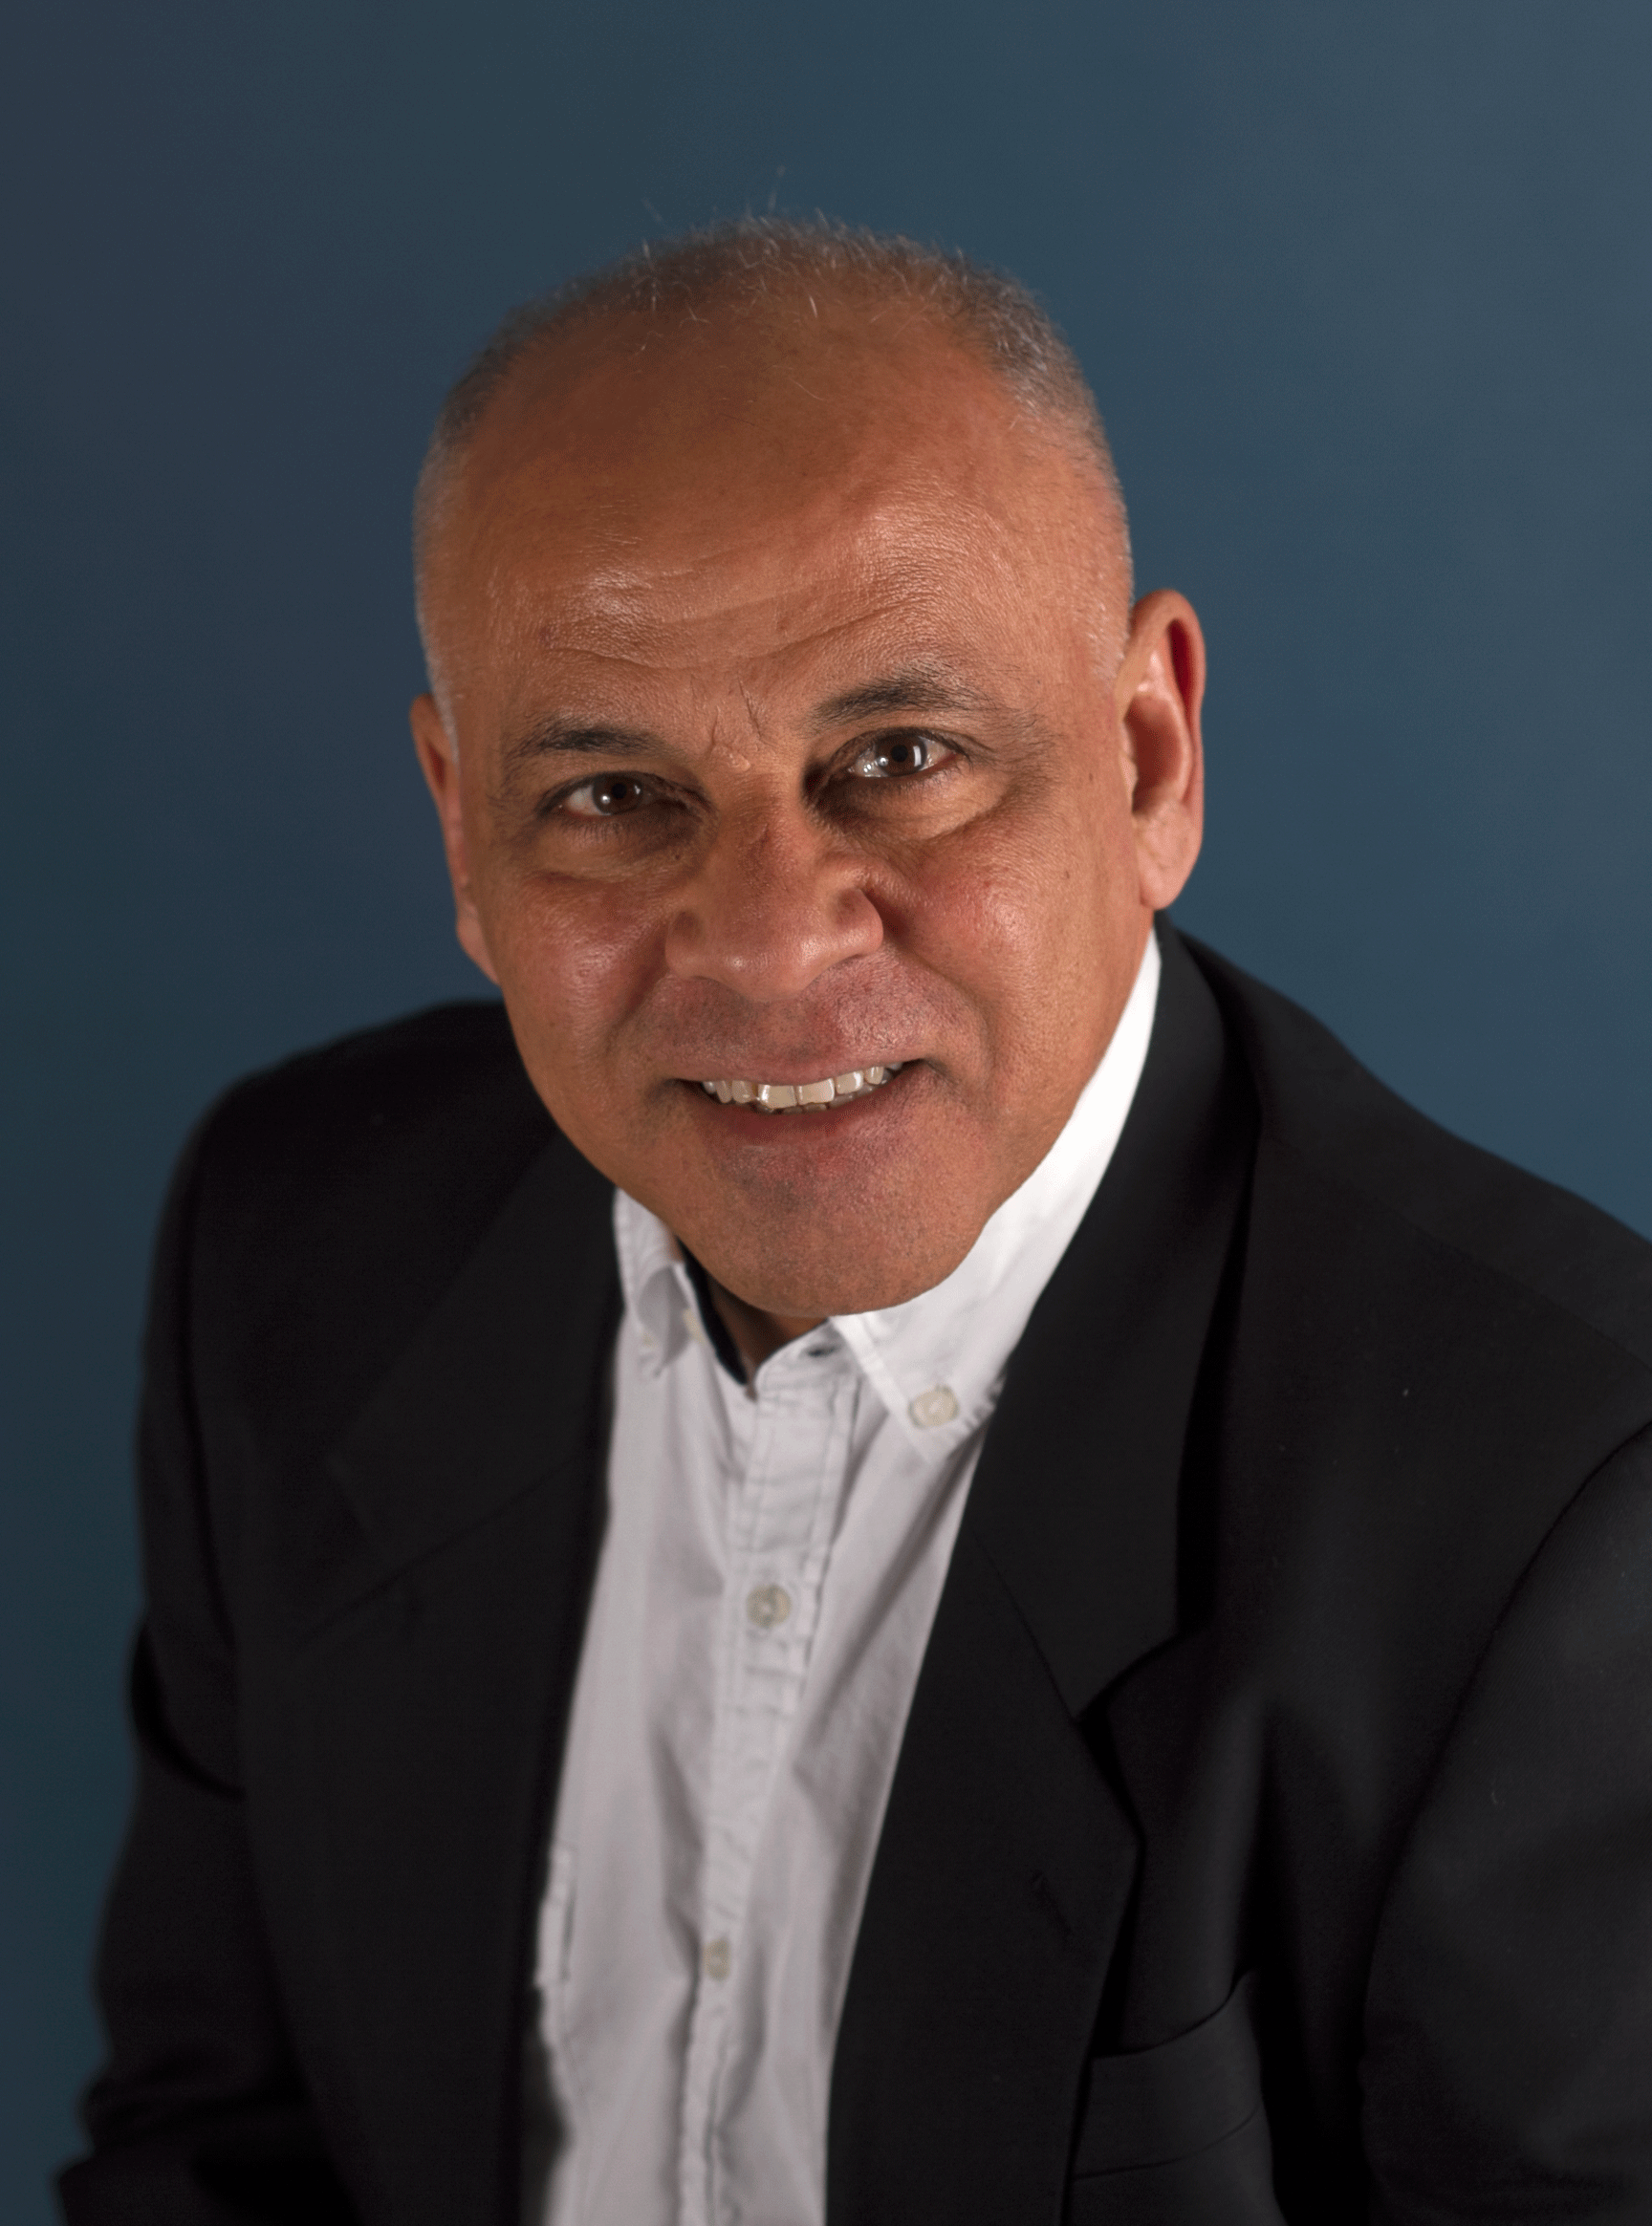
Educator, Percussionist, Composer Marlon Simon was born in the small town of Cardón Venezuela. His first contact with music, at the age of 10, came from his father, Hadsy Simon, a philosopher with deep insights into spiritualism and metaphysics, and guitarist and vocalist. “Whenever we had a visitor my father used to take his guitar out and invite me to join him, playing on a little bongo. Later on, I drove him nuts. When I reached the age of 15, he bought me a set of timbales. I learned most of the Latin rudiments on my own. Listening mostly to dance bands, salsa, merengue and other South American dance music styles helped me begin playing with top local bands in the area, Marlon says. By the time he was 18, Marlon had organized his own band and had begun performing locally at concerts and clubs, sometimes opening for major national acts. His interest in jazz was sparked when he was 19 and a friend brought him a video he had recorded of Dizzy Gillespie, Chick Corea and Miroslav Vitous, and others. Marlon also quickly became hooked, and with an abiding interest in jazz and African-originated music he came to the United States in 1987 and began formal studies on drums at The University of The Arts in Philadelphia. In 1988, he received a grant from the Philadelphia Music Foundation. He moved to New York in 1989, and later obtained his Bachelor of Arts degree in Jazz and Contemporary Music from the New School for Social Research. During his studies, Marlon worked locally in the city, developing his unique style and gaining the respect of noted jazz and Latin musicians.
Marlon has also worked with such luminaries as Hilton Ruíz, Dave Valentin, Jerry González, Chucho Valdés and Bobby Watson to mention a few. After several years, he formed his own Latin jazz ensemble, Marlon Simon and The Nagual Spirits. With his own group Marlon got the opportunity to showcase his talents as a composer and drummer, defining a distinct approach to Latin Jazz. As a leader Marlon has since released: The Music of Marlon Simon (K-Jazz, 1999), followed by Rumba a la Patato (Cubop Records 2000) and Live in La Paz, Bolivia (Intrigue Records, 2005) and later In Case You Missed It (Jazzheads, 2006). After spending much time in France, Marlon forged an alliance with several local musicians and produced two critically received recordings. These are: French Latin Jazz Project - Afrocuban & Live (Chantilly Negra Productions, 2008) and Venezuelan French Project (Proyecto Venezolano Francés) - Racines (Raíces) (Chantilly Negra Productions, 2011). The 2008 recording is a prodigious example of excellence in Latin Jazz while the 2011 recording reflects the collision between Venezuelan and French-Celtic-Music. Marlon’s music has frequently taken him around the globe apart from France to Canada, Poland, Australia, Netherland Antilles, USA and, of course, various countries in South America.
Marlon has also appeared in numerous recordings with other well-known jazz greats. Parallel to his career as a performer, he has also become recognized as an in-demand educator and specialist in Afro-Caribbean rhythms. He has conducted workshops, master classes and seminars at Temple University, Penn State University, Rutgers University and the New Jersey ABC conference for public school teachers, the University of the Arts and Perkings Center for the Arts. Marlon has also served as an Artist-in-Residence at numerous public and private schools in the tri-state area and abroad. In the year 2000 he was named the distinguished teaching artist in recognition of a history of commitment of excellence in the Arts and Education and for receiving the highest regard of his Arts and Education peers issued by the New Jersey State Council of the Arts. In the year 2001 Marlon received The New Jersey Governor's award in Arts and Education. In June 2001 he performed as a guest solo artist and conducted seminars at The Ultimate Drummers weekend, the largest drumming event in the southern hemisphere in Melbourne, Australia. In 2003, as a special invitee of the US State Department Marlon Simon and The Nagual Spirits were selected to present two international concerts representing the US as an ambassador for excellence in artistry developed in the United States.

